Review bagian project :

1. **Rainbow Seven Siege** needs a new **logo** that represents the image of the game that is susceptible to the game’s season and operators. Consider the **customer segment, shape and colors** when designing the **logo**. The logo will be created using **Adobe Photoshop**, ensure that no layers are **merged**.

**Jawaban review :**  
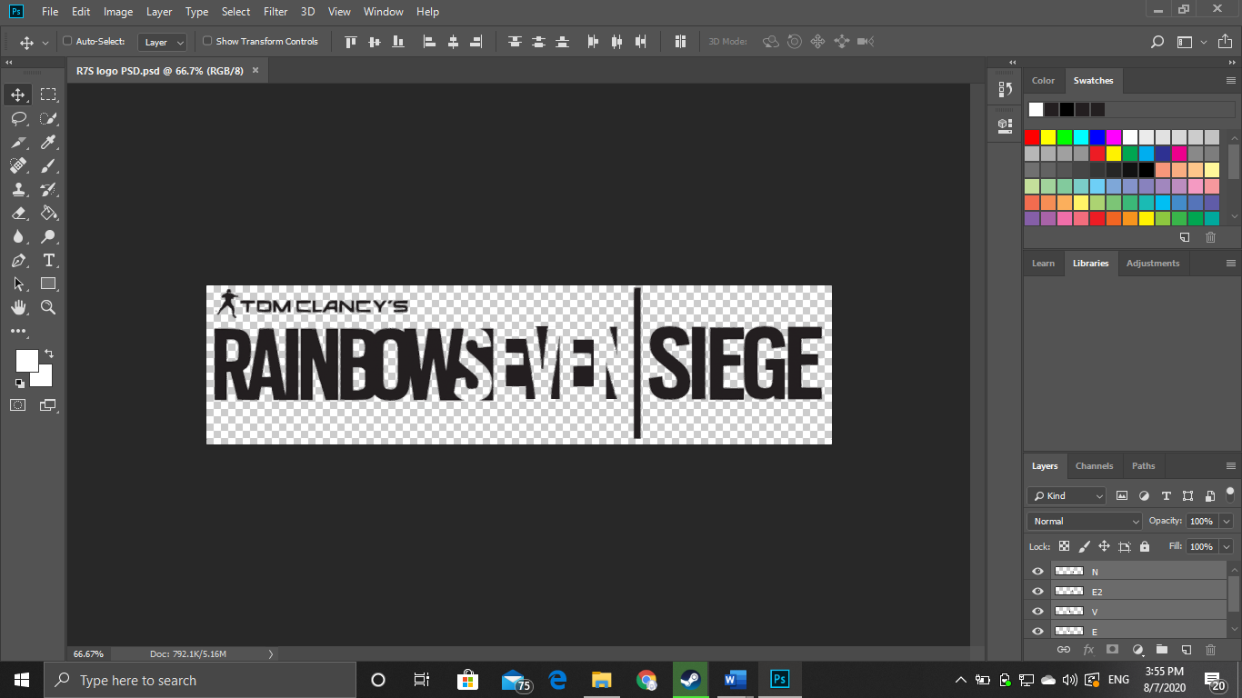  
Terdapat logo baru berwarna hitam yang menggunakan adobe photoshop dan layer tidak di merged.

1. **Ubipost** wants you to design the blueprint of your homepage first before starting the development of the HTML files. The blueprint will be created using **Adobe Photoshop**. **Ensure the blueprint that you create matches the website that you will create later**. The homepage blueprint must contain **header, navigation, content, and footer**.

**Jawaban review :**  
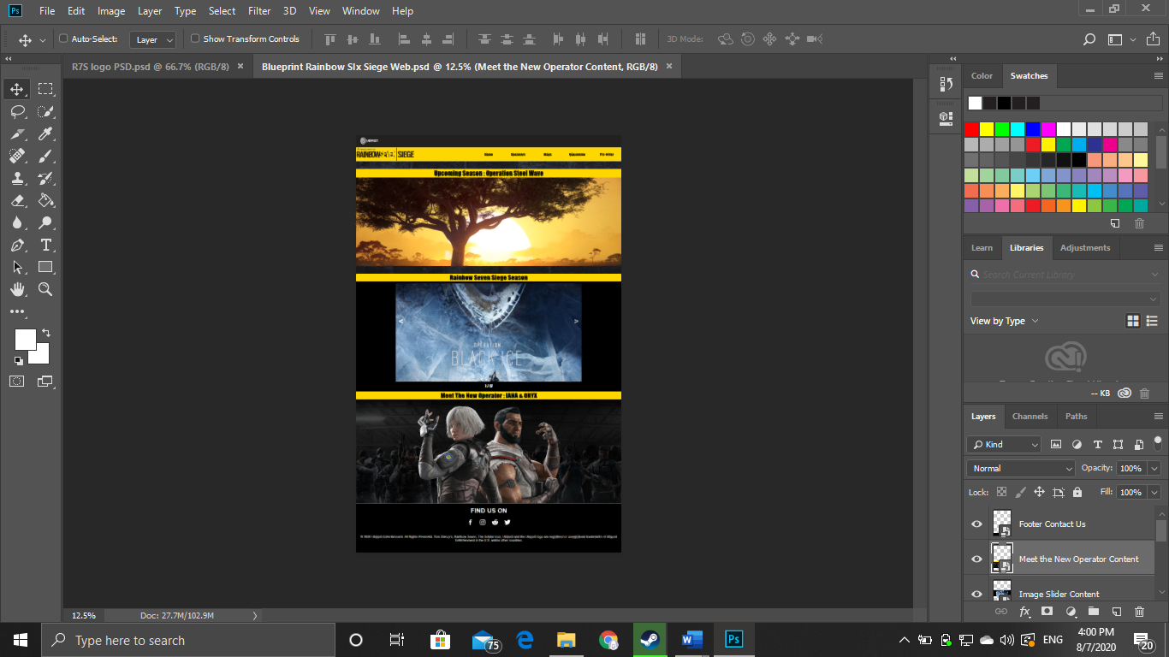  
Terdapat blueprint dari website yang mengandung header, navigation, content, dan footer (penjelasan bagian terdapat pada penamaan layer).

1. **Ubipost** wants its website to provide information about its game, such as a **list of maps** and **characters** in the game.

**Jawaban review :**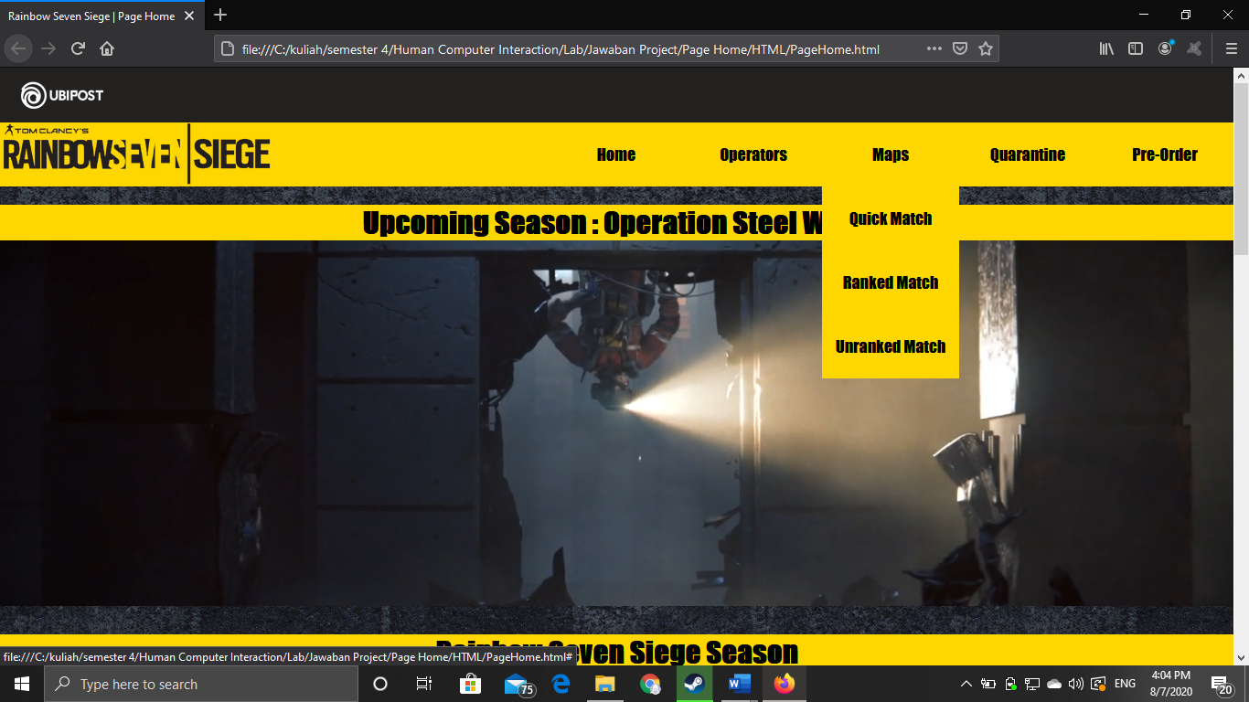

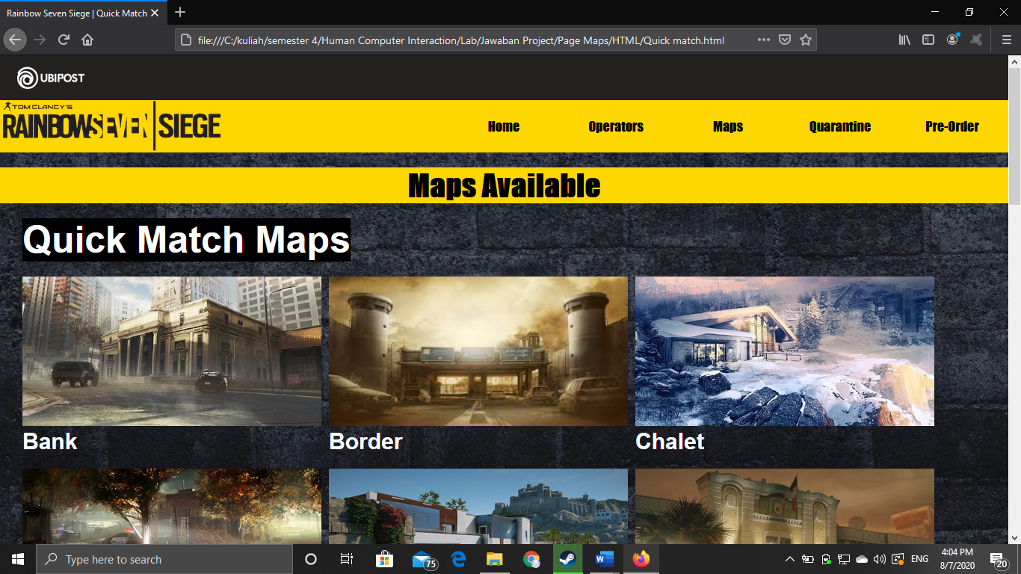

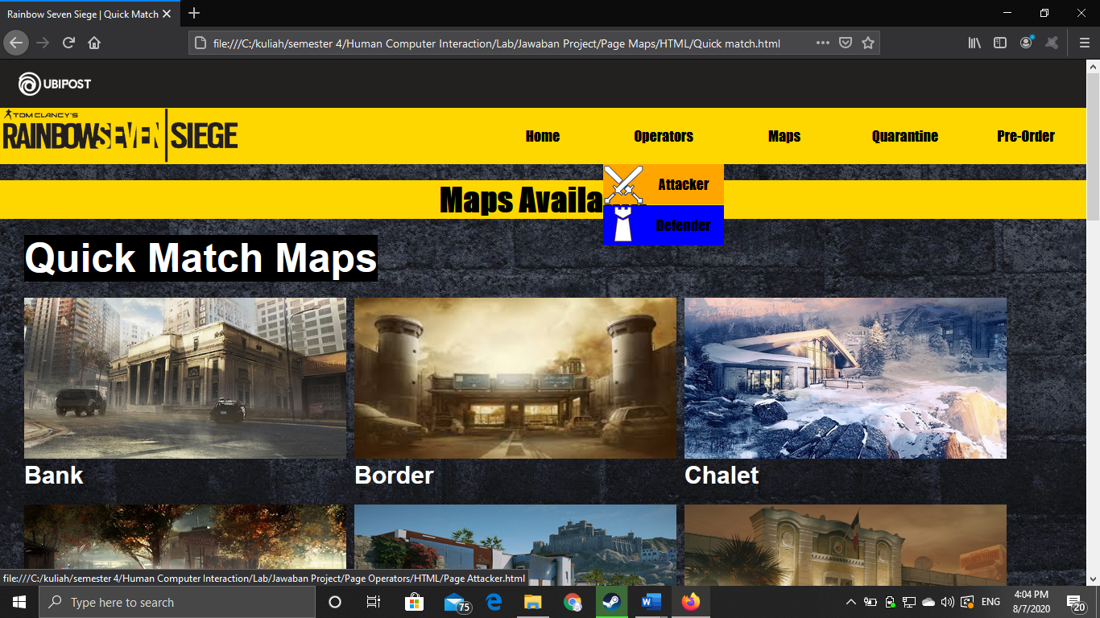

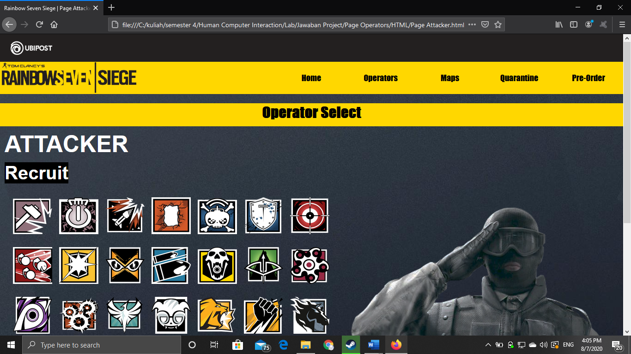

Terdapat list dari map dan karakter.

1. **Ubipost** wants you to build an attractive, appealing and functional website. Furthermore, **Ubipost** wants you to create a website with a **responsive design**. **The website should be accessible by phone**. To achieve that, use **5 kinds of CSS property** and **JavaScript**. Use **Meta** **viewport** **tag** and **media** **screen** **rule** that will be applied if the screen is **below** **800px** screen.

**Jawaban review :**

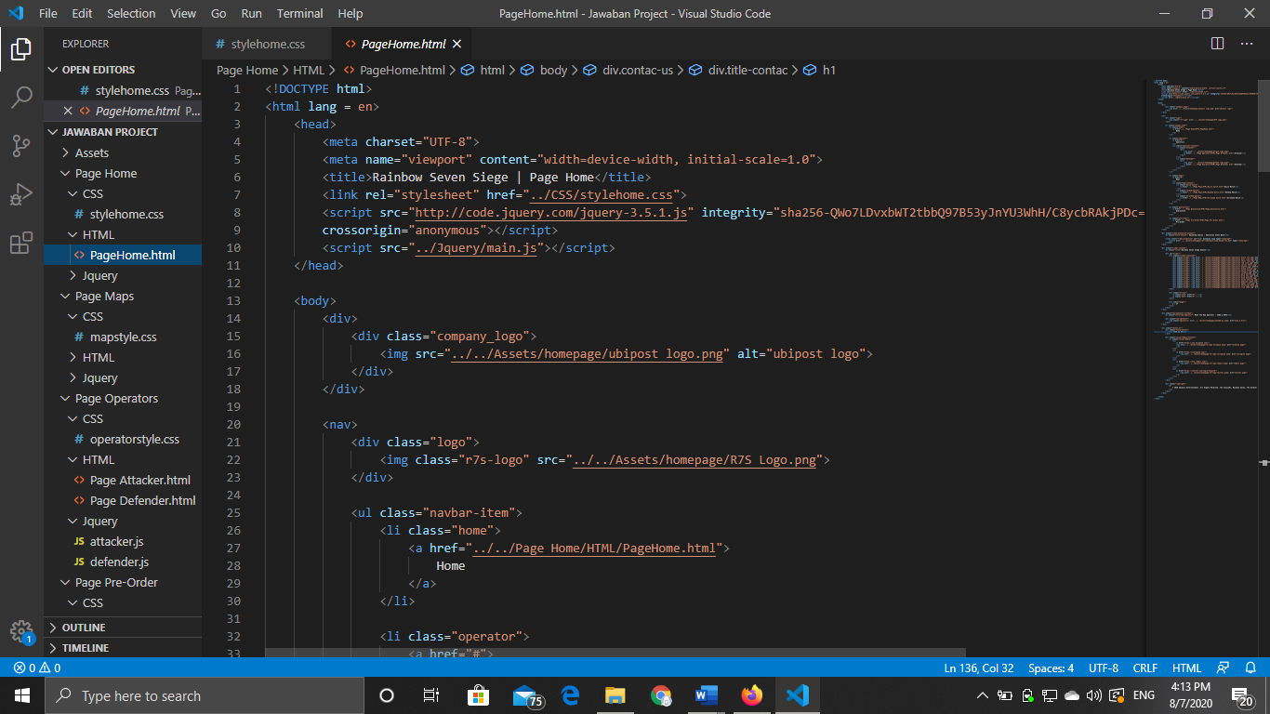

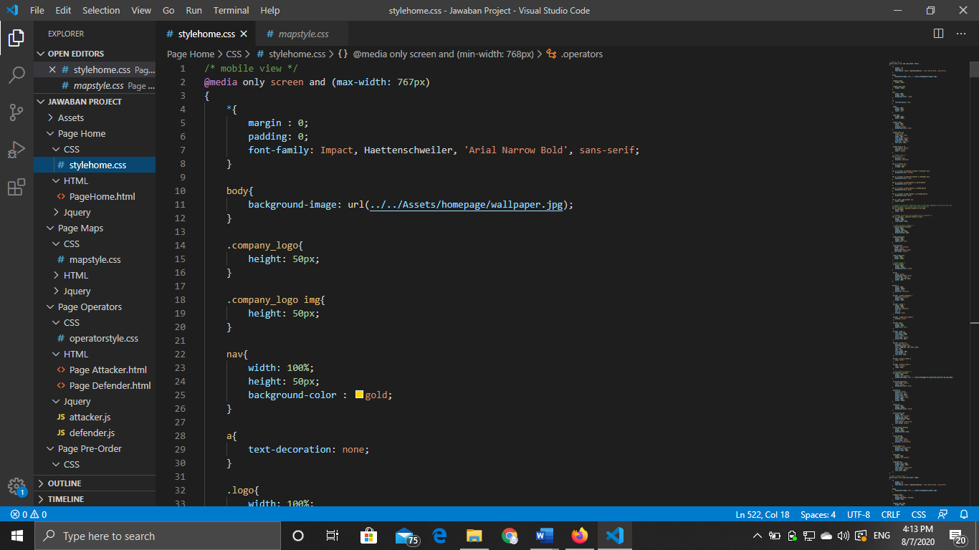

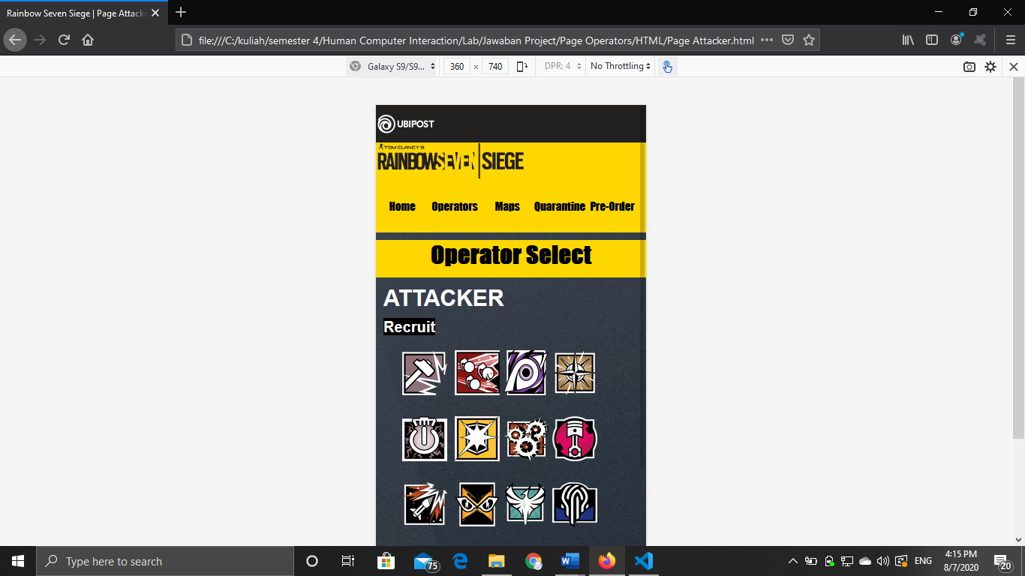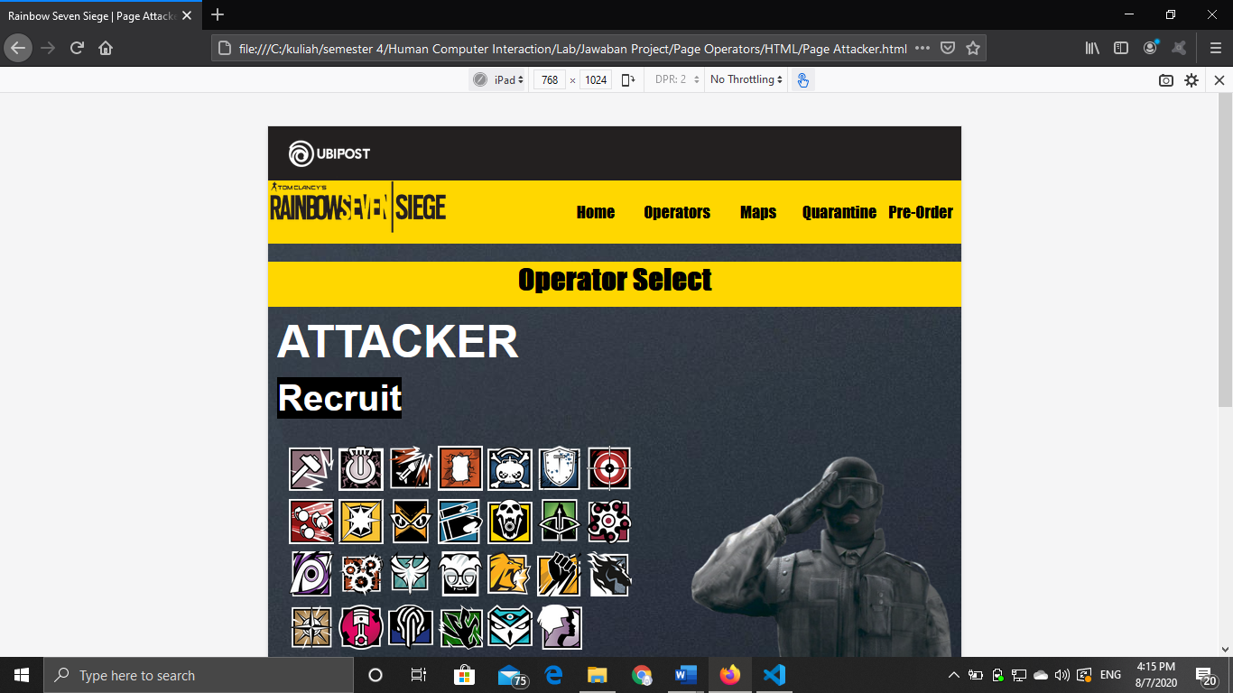

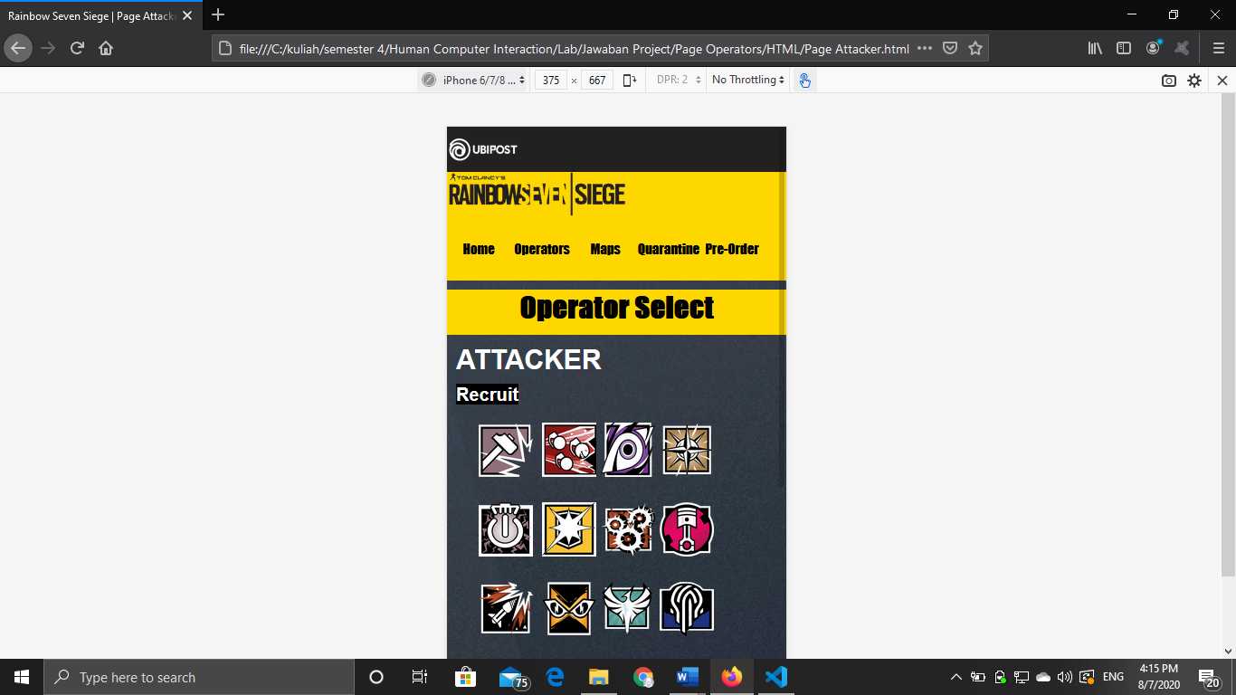

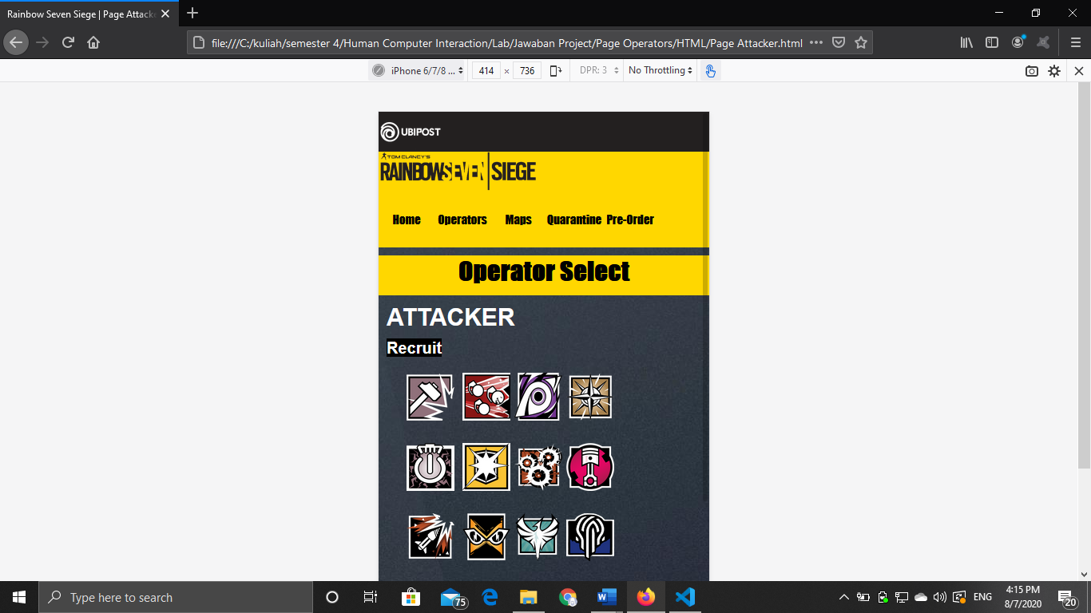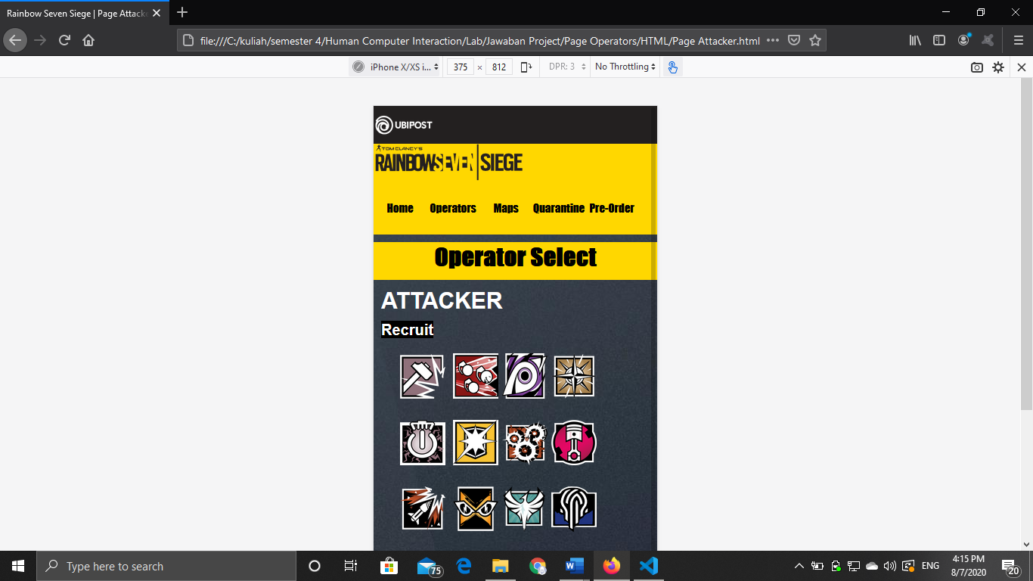

Semua resolusi yang di bawah 800px bisa ditampilkan

1. The website consists of 5 main pages. They are **Home, Quarantine, Operators, Maps, and Pre-order.** You need to create a **navigation menu using Drop down** menu using **CSS**. Here are the requirements for the website:
   * **Home**

**Ubipost** wants to have an **image slider** on this page **using JQuery** to **show all previous seasons events and currently running events**. On the home page,you also need to provide some information such as the latest news from previous updates and upcoming updates.

* + **Operators**

**Ubipost** wants you to make a page that shows the **information of the characters** called the operator that can be chosen in the game. The information that should be provided is at least the **character’s name, character’s images**. You are also **free to add another component** such as the character’s story and character’s specialty.

* + **Maps**

This page provides **information** about **available maps** that are included in **Rainbow Seven Siege**. Each map has information that should be provided, such as the **map’s image** and **title**.

* + **Quarantine**

This page provides information about the new mode inside the game called **Rainbow Seven Quarantine**. The **information** that **should be provided** such as **teaser images**, a **brief description of the new modes**, **release date**, etc.

* + **Pre-Order**

**Ubipost** wants you to make a page that helps the user to pre-order the game. User needs to submit some personal information such as **username**, **email**, **password**, **address**, **number of copies**, **type of the game** and **Terms and Service agreement.** You are also asked to create **5 types of validation using JavaScript** and **don’t use a regular expression.**

**Jawaban review :**